# List Interface

1. **Reverse a List**Write a program to reverse the elements of a given List without using built-in reverse methods. Implement it for both ArrayList and LinkedList.  
   **Example**:  
   Input: [1, 2, 3, 4, 5] → Output: [5, 4, 3, 2, 1].

|  |
| --- |
| package collections;  import java.util.*;  public class ReverseList {  public static <T> void reverseList(List<T> list) {  int left = 0, right = list.size() - 1;  while (left < right) {  T temp = list.get(left);  list.set(left, list.get(right));  list.set(right, temp);  left++;  right--;  }  }   public static void main(String[] args) {  List<Integer> list = new ArrayList<>(Arrays.asList(1, 2, 3, 4, 5));  reverseList(list);  System.out.println(list); // [5, 4, 3, 2, 1]  } } |

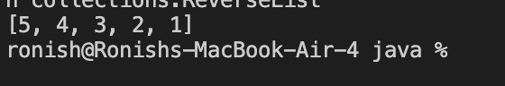

1. **Find Frequency of Elements**Given a list of strings, count the frequency of each element and return the results in a Map<String, Integer>.  
   **Example**:  
   Input: ["apple", "banana", "apple", "orange"] → Output: {apple=2, banana=1, orange=1}.

|  |
| --- |
| package collections;  import java.util.*;  public class FrequencyCounter {  public static Map<String, Integer> frequency(List<String> list) {  Map<String, Integer> map = new HashMap<>();  for (String s : list) {  map.put(s, map.getOrDefault(s, 0) + 1);  }  return map;  }   public static void main(String[] args) {  List<String> list = Arrays.asList("apple", "banana", "apple", "orange");  System.out.println(frequency(list)); // {apple=2, banana=1, orange=1}  } } |

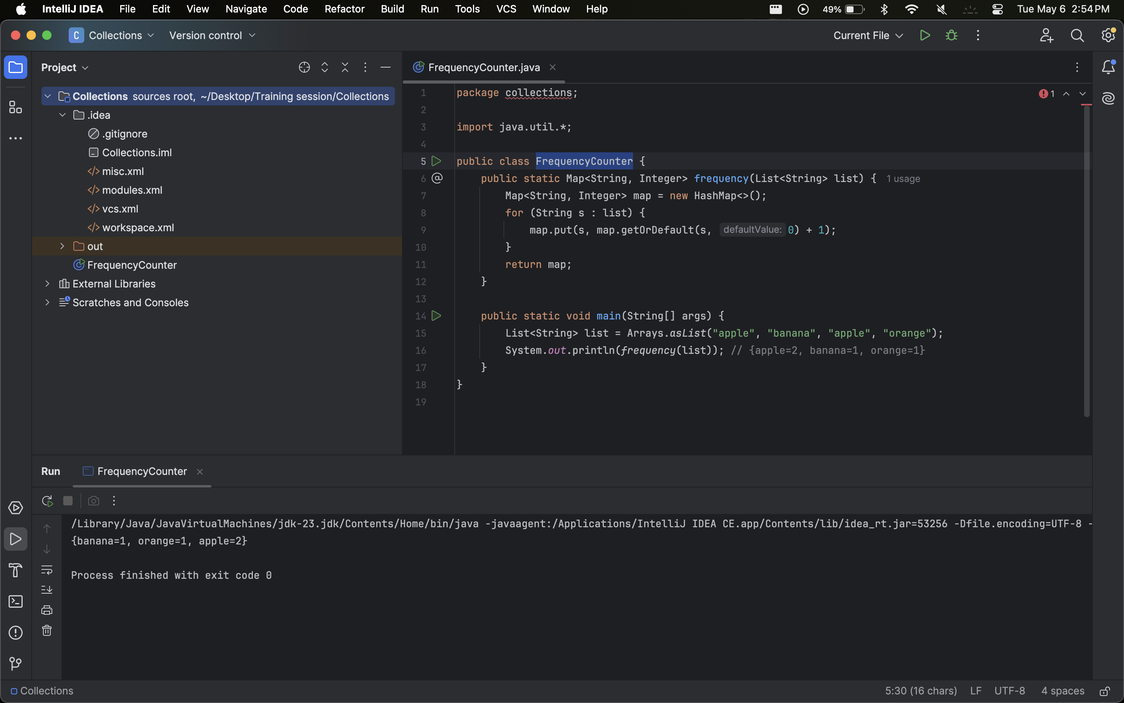

1. **Rotate Elements in a List**Rotate the elements of a list by a given number of positions.  
   **Example**:  
   Input: [10, 20, 30, 40, 50], rotate by 2 → Output: [30, 40, 50, 10, 20].

|  |
| --- |
| package collections;  import java.util.*;  public class ListRotator {  public static <T> void rotate(List<T> list, int k) {  int n = list.size();  k = k % n;  List<T> rotated = new ArrayList<>();  rotated.addAll(list.subList(k, n));  rotated.addAll(list.subList(0, k));  list.clear();  list.addAll(rotated);  }   public static void main(String[] args) {  List<Integer> list = new ArrayList<>(Arrays.asList(10, 20, 30, 40, 50));  rotate(list, 2);  System.out.println(list); // [30, 40, 50, 10, 20]  } } |

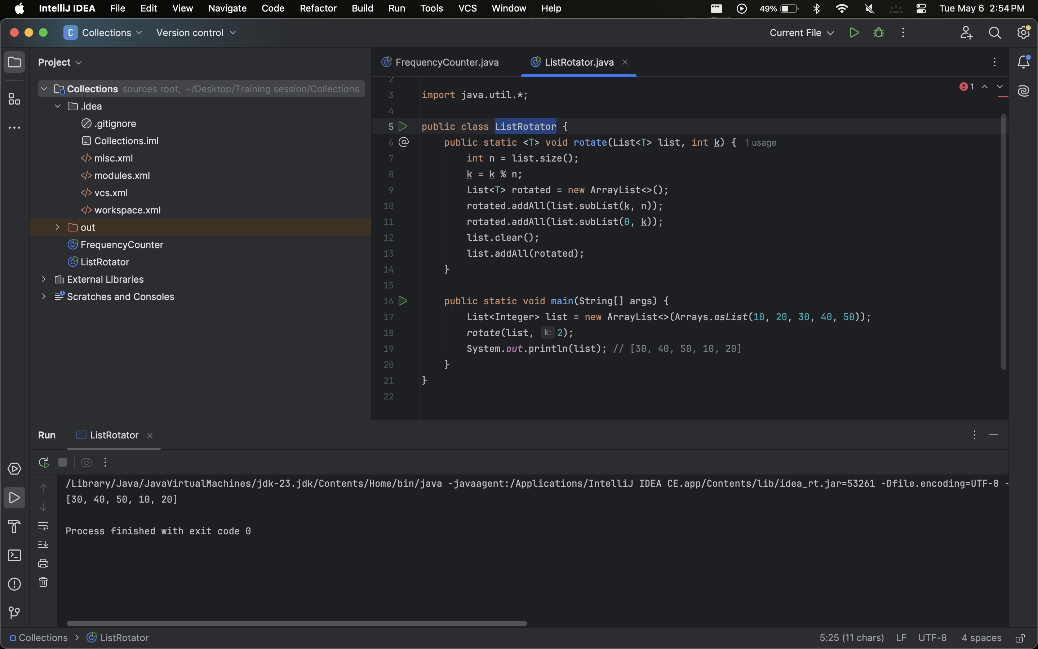

1. **Remove Duplicates While Preserving Order**Remove duplicate elements from a list while maintaining the original order of elements.  
   **Example**:  
   Input: [3, 1, 2, 2, 3, 4] → Output: [3, 1, 2, 4].

|  |
| --- |
| package collections;  import java.util.*;  public class RemoveDuplicates {  public static <T> List<T> removeDuplicates(List<T> list) {  Set<T> seen = new LinkedHashSet<>(list);  return new ArrayList<>(seen);  }   public static void main(String[] args) {  List<Integer> list = Arrays.asList(3, 1, 2, 2, 3, 4);  System.out.println(removeDuplicates(list)); // [3, 1, 2, 4]  } } |

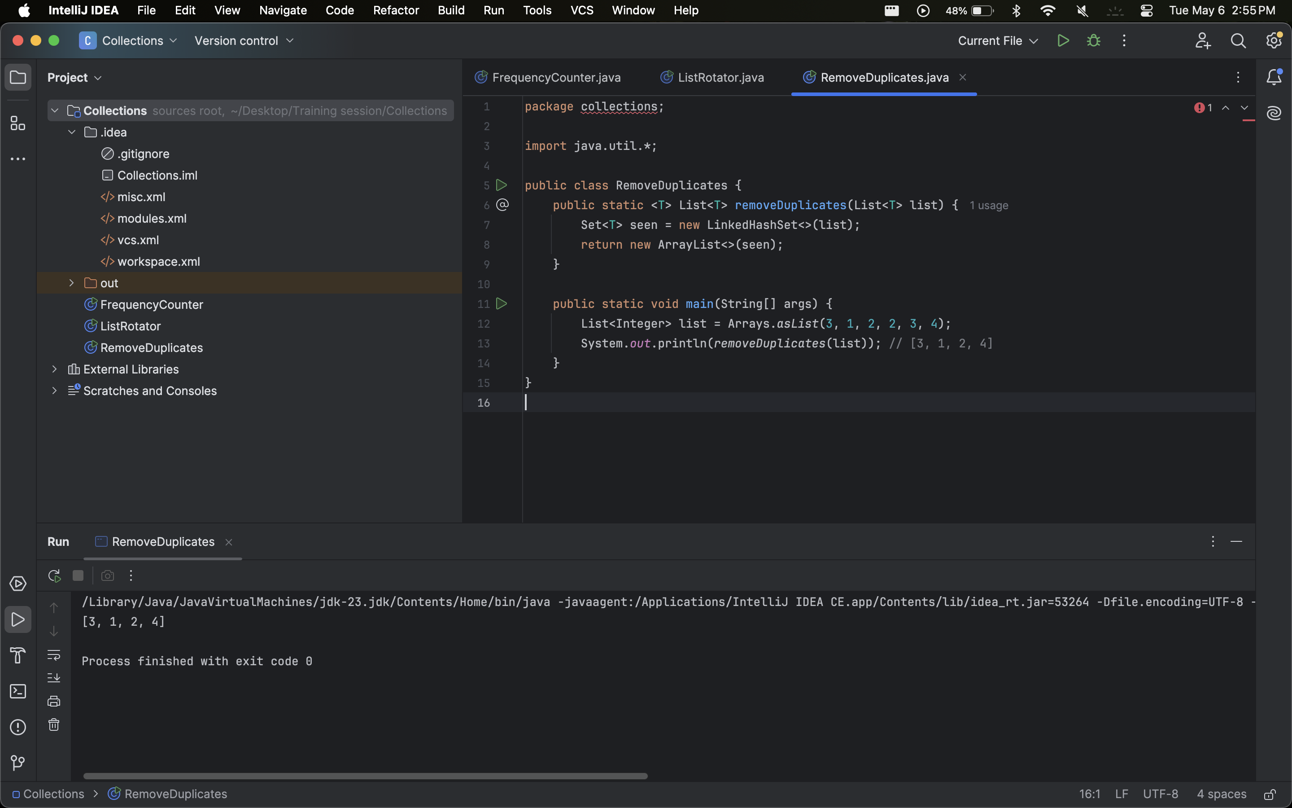

1. **Find the Nth Element from the End**Given a singly linked list (use LinkedList), find the Nth element from the end without calculating its size.  
   **Example**:  
   Input: [A, B, C, D, E], N=2 → Output: D.

|  |
| --- |
| package collections;  import java.util.*;  public class NthFromEnd {  public static <T> T findNthFromEnd(LinkedList<T> list, int n) {  Iterator<T> lead = list.iterator();  Iterator<T> follow = list.iterator();  for (int i = 0; i < n; i++) {  if (lead.hasNext()) lead.next();  else return null;  }  while (lead.hasNext()) {  lead.next();  follow.next();  }  return follow.next();  }   public static void main(String[] args) {  LinkedList<String> list = new LinkedList<>(Arrays.asList("A", "B", "C", "D", "E"));  System.out.println(findNthFromEnd(list, 2)); // D  } } |

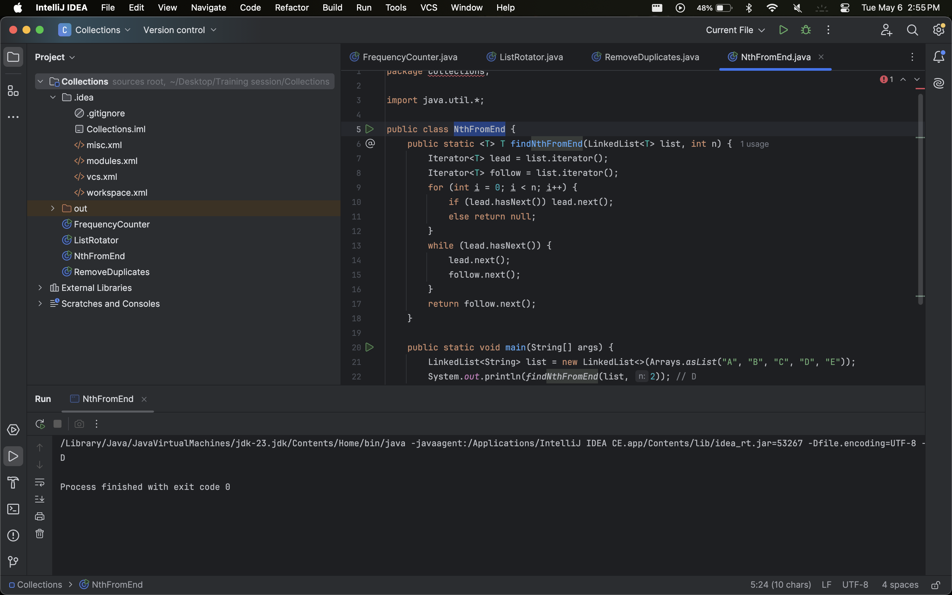

### 

# 

# Set Interface

1. **Check if Two Sets Are Equal**Compare two sets and determine if they contain the same elements, regardless of order.  
   **Example**:  
   Set1: {1, 2, 3}, Set2: {3, 2, 1} → Output: true.

|  |
| --- |
| package collections;  import java.util.*;  public class SetEquality {  public static <T> boolean areSetsEqual(Set<T> s1, Set<T> s2) {  return s1.equals(s2);  }   public static void main(String[] args) {  Set<Integer> s1 = new HashSet<>(Arrays.asList(1, 2, 3));  Set<Integer> s2 = new HashSet<>(Arrays.asList(3, 2, 1));  System.out.println(areSetsEqual(s1, s2)); // true  } } |

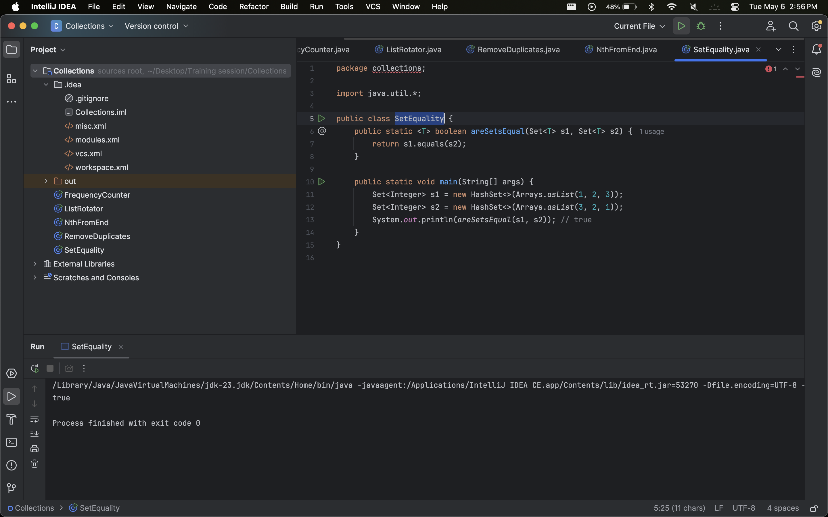

1. **Union and Intersection of Two Sets**Given two sets, compute their union and intersection.  
   **Example**:  
   Set1: {1, 2, 3}, Set2: {3, 4, 5} → Union: {1, 2, 3, 4, 5}, Intersection: {3}.

|  |
| --- |
| package collections;  import java.util.*;  public class SetOperations {  public static <T> Set<T> union(Set<T> s1, Set<T> s2) {  Set<T> result = new HashSet<>(s1);  result.addAll(s2);  return result;  }   public static <T> Set<T> intersection(Set<T> s1, Set<T> s2) {  Set<T> result = new HashSet<>(s1);  result.retainAll(s2);  return result;  }   public static void main(String[] args) {  Set<Integer> s1 = new HashSet<>(Arrays.asList(1, 2, 3));  Set<Integer> s2 = new HashSet<>(Arrays.asList(3, 4, 5));  System.out.println("Union: " + union(s1, s2)); // [1, 2, 3, 4, 5]  System.out.println("Intersection: " + intersection(s1, s2)); // [3]  } } |

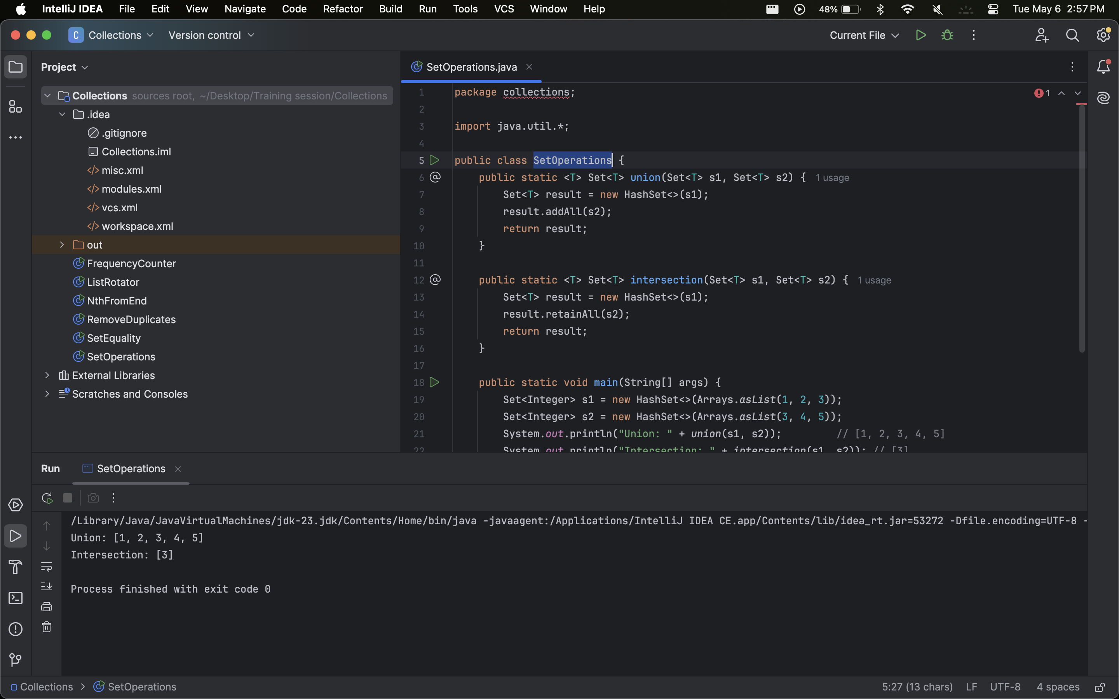

1. **Symmetric Difference**Find the symmetric difference (elements present in either set but not in both) of two sets.  
   **Example**:  
   Set1: {1, 2, 3}, Set2: {3, 4, 5} → Output: {1, 2, 4, 5}.

|  |
| --- |
| package collections;  import java.util.*;  public class SymmetricDifference {  public static <T> Set<T> symmetricDifference(Set<T> s1, Set<T> s2) {  Set<T> result = new HashSet<>(s1);  result.addAll(s2);  Set<T> intersection = new HashSet<>(s1);  intersection.retainAll(s2);  result.removeAll(intersection);  return result;  }   public static void main(String[] args) {  Set<Integer> s1 = new HashSet<>(Arrays.asList(1, 2, 3));  Set<Integer> s2 = new HashSet<>(Arrays.asList(3, 4, 5));  System.out.println(symmetricDifference(s1, s2)); // [1, 2, 4, 5]  } } |

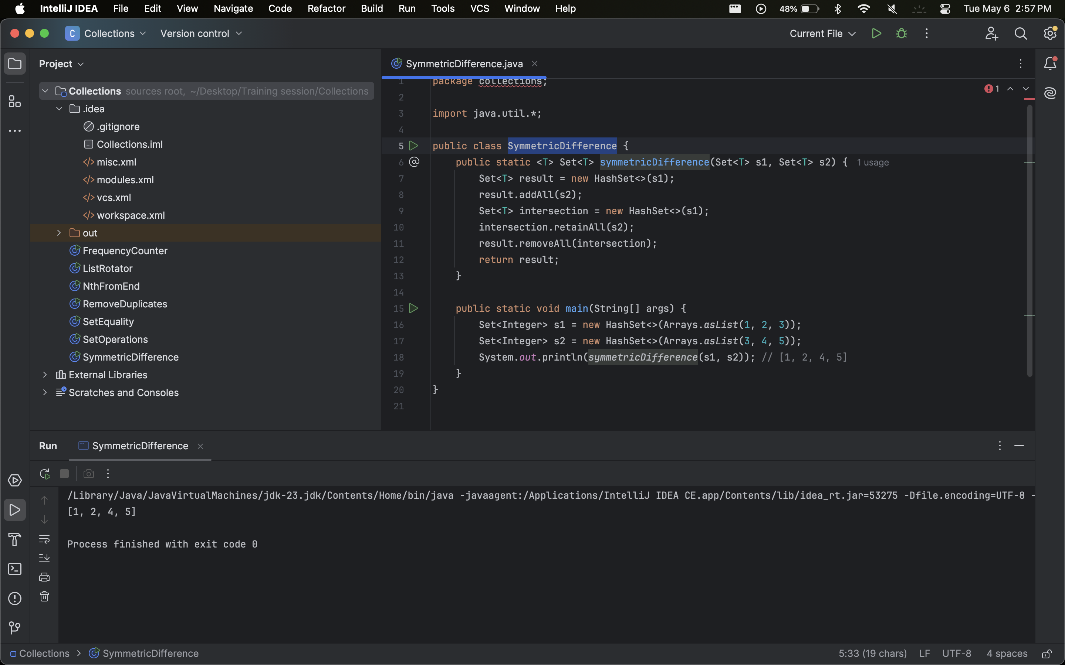

1. **Convert a Set to a Sorted List**Convert a HashSet of integers into a sorted list in ascending order.  
   **Example**:  
   Input: {5, 3, 9, 1} → Output: [1, 3, 5, 9].

|  |
| --- |
| package collections;  import java.util.*;  public class SetToSortedList {  public static List<Integer> sortedListFromSet(Set<Integer> set) {  List<Integer> list = new ArrayList<>(set);  Collections.sort(list);  return list;  }   public static void main(String[] args) {  Set<Integer> set = new HashSet<>(Arrays.asList(5, 3, 9, 1));  System.out.println(sortedListFromSet(set)); // [1, 3, 5, 9]  } } |

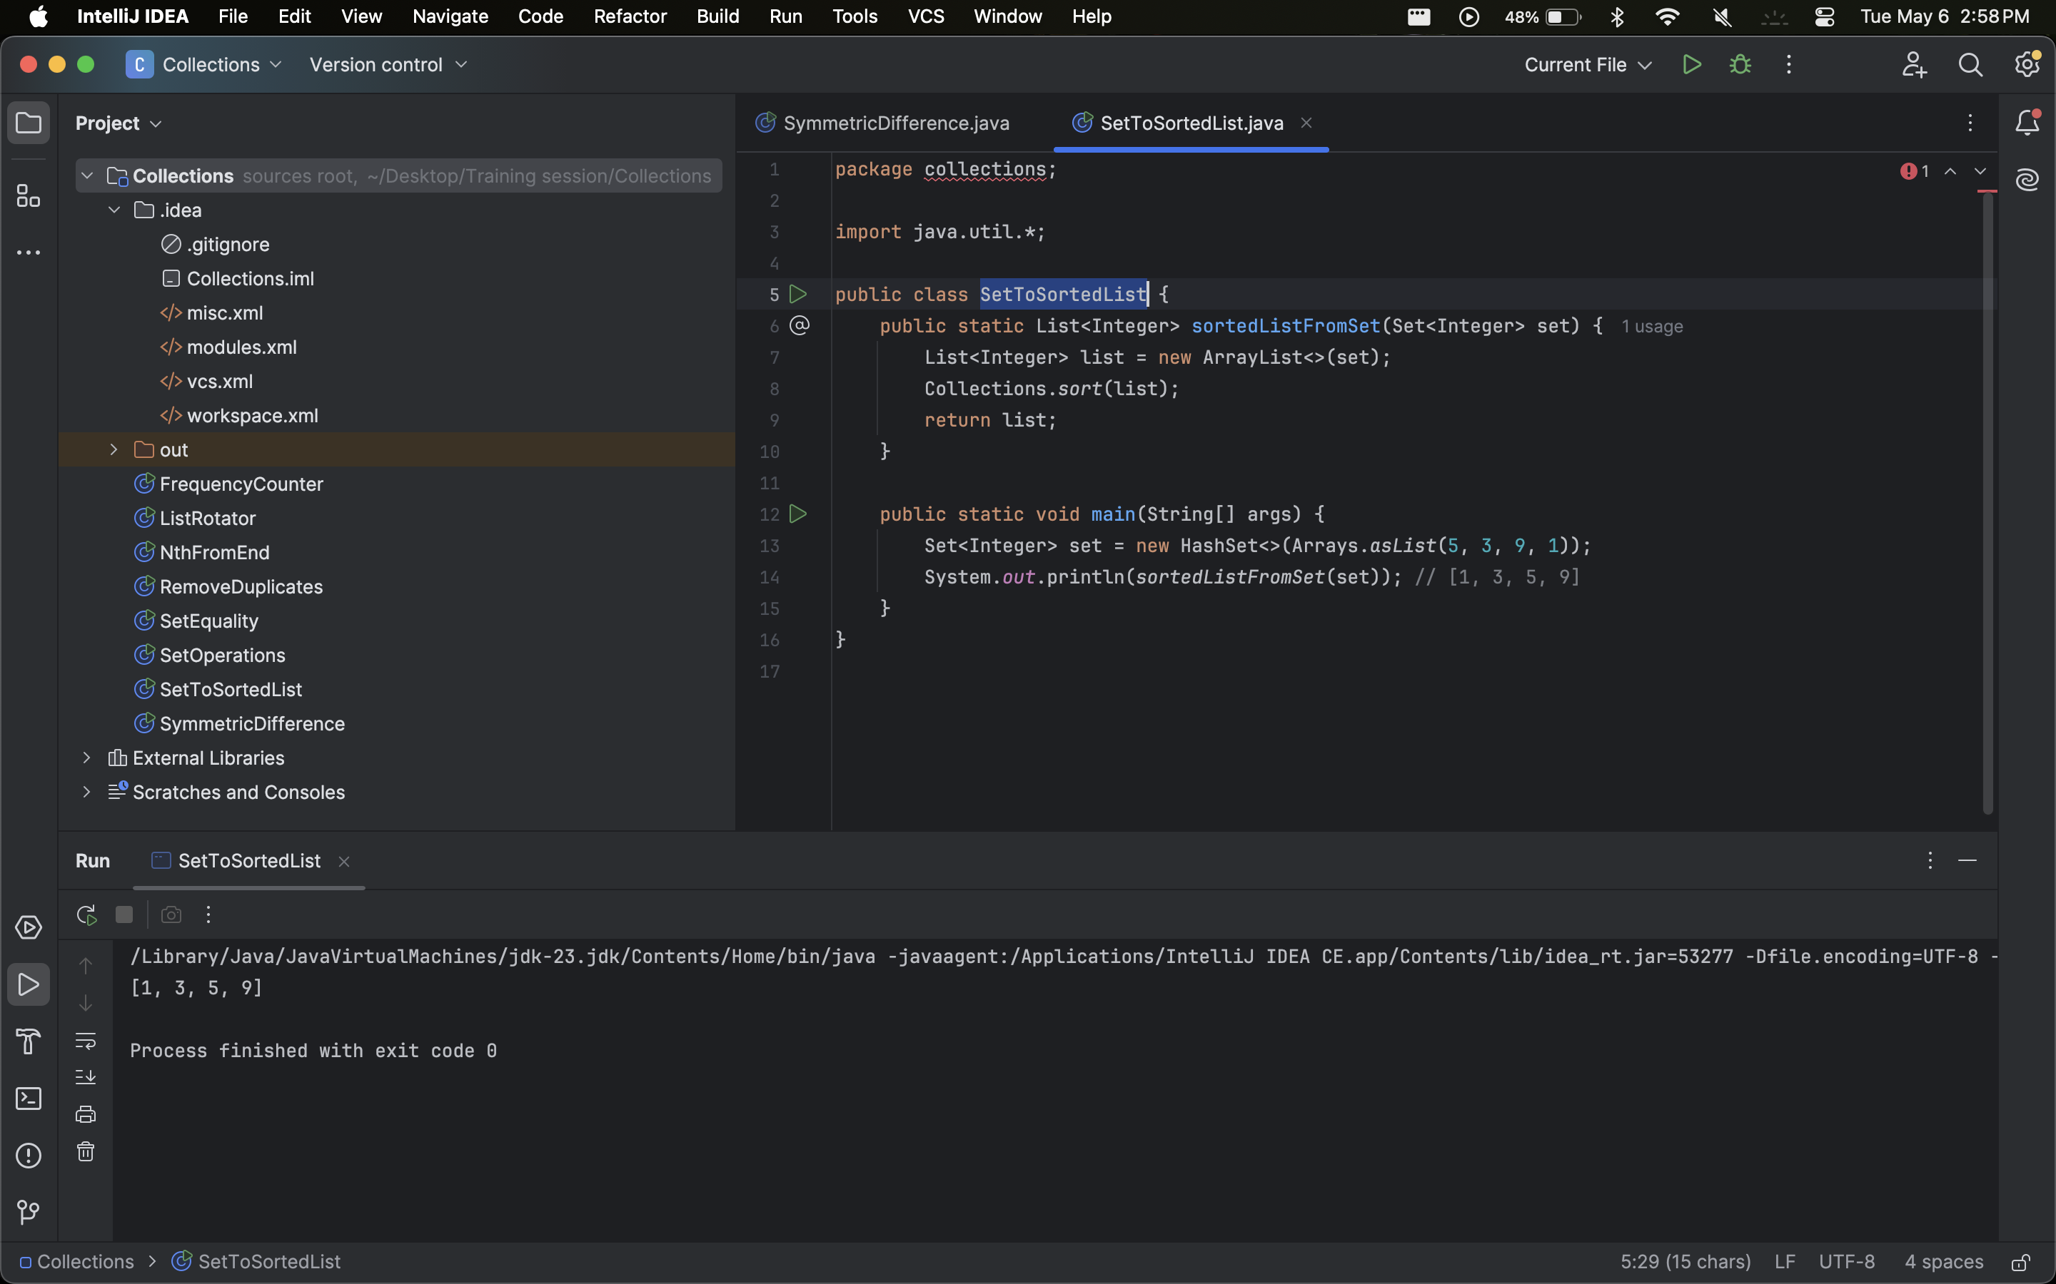

1. **Find Subsets**Check if one set is a subset of another.  
   **Example**:  
   Set1: {2, 3}, Set2: {1, 2, 3, 4} → Output: true.

|  |
| --- |
| package collections; import java.util.*;  public class SubsetCheck {  public static <T> boolean isSubset(Set<T> subset, Set<T> superset) {  return superset.containsAll(subset);  }   public static void main(String[] args) {  Set<Integer> s1 = new HashSet<>(Arrays.asList(2, 3));  Set<Integer> s2 = new HashSet<>(Arrays.asList(1, 2, 3, 4));  System.out.println(isSubset(s1, s2)); // true  } } |

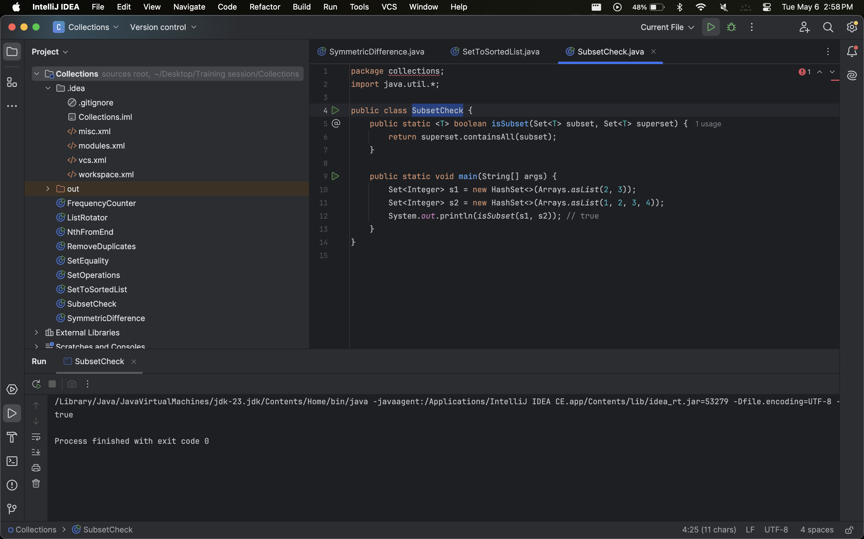

**Insurance Policy Management System**

Each policy has the following attributes:

● Policy Number (unique identifier)

● Policyholder Name

● Expiry Date

● Coverage Type (e.g., Health, Auto, Home)

● Premium Amount

**Requirements:**

1. Store Unique Policies: Implement methods to store policies using different

types of sets (HashSet, LinkedHashSet, TreeSet), each serving different

purposes:

* HashSet for quick lookups.
* LinkedHashSet to maintain the order of insertion.
* TreeSet to maintain policies sorted by expiry date.

2. Retrieve Policies: Implement methods to retrieve and display policies based on

certain criteria:

* All unique policies.
* Policies expiring soon (within the next 30 days
* Policies with a specific coverage type.
* Duplicate policies based on policy numbers.

3. Performance Comparison: Compare the performance of HashSet,

LinkedHashSet, and TreeSet in terms of adding, removing, and searching for

policies.

### 

# Queue Interface

1. **Reverse a Queue**Reverse the elements of a queue using only queue operations (e.g., add, remove, isEmpty).  
   **Example**:  
   Input: [10, 20, 30] → Output: [30, 20, 10].

|  |
| --- |
| package collections;  import java.util.*;  public class ReverseQueue {  public static <T> void reverse(Queue<T> queue) {  if (queue.isEmpty()) return;  T temp = queue.remove();  reverse(queue);  queue.add(temp);  }   public static void main(String[] args) {  Queue<Integer> queue = new LinkedList<>(List.of(10, 20, 30));  reverse(queue);  System.out.println(queue); // [30, 20, 10]  } } |

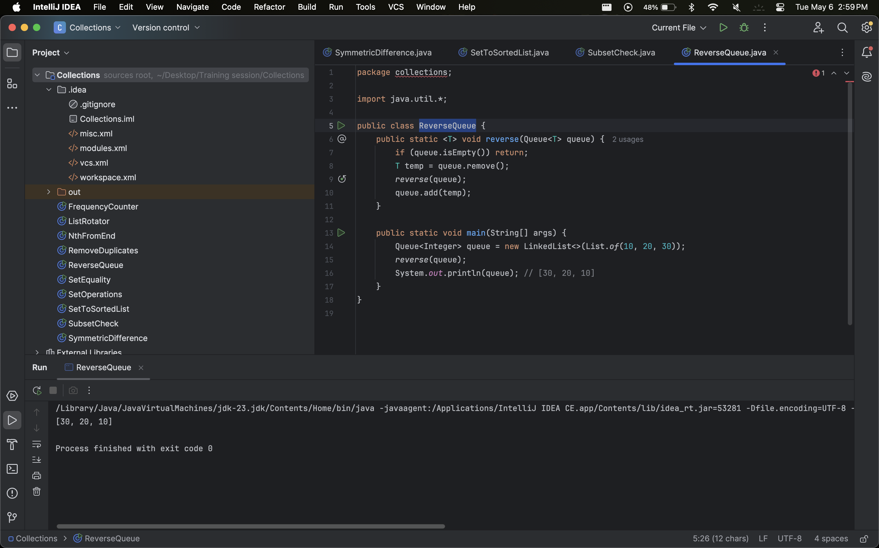

1. **Generate Binary Numbers Using a Queue**Generate the first N binary numbers (as strings) using a queue.  
   **Example**:  
   N=5 → Output: ["1", "10", "11", "100", "101"].

|  |
| --- |
| package collections; import java.util.*;  public class BinaryGenerator {  public static List<String> generateBinary(int n) {  List<String> result = new ArrayList<>();  Queue<String> queue = new LinkedList<>();  queue.add("1");  while (n-- > 0) {  String curr = queue.poll();  result.add(curr);  queue.add(curr + "0");  queue.add(curr + "1");  }  return result;  }   public static void main(String[] args) {  System.out.println(generateBinary(5)); // [1, 10, 11, 100, 101]  } } |

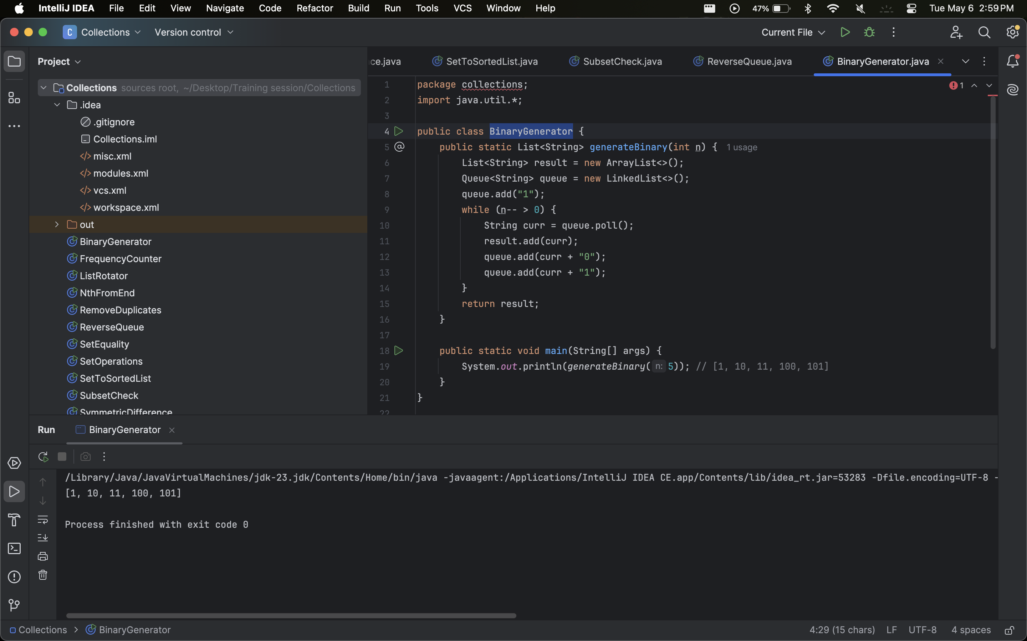

1. **Hospital Triage System**Simulate a hospital triage system using a PriorityQueue where patients with higher severity are treated first.  
   **Example**:  
   Patients: [("John", 3), ("Alice", 5), ("Bob", 2)] → Order: Alice, John, Bob.

|  |
| --- |
| package collections;  import java.util.*;  class Patient {  String name;  int severity;   public Patient(String name, int severity) {  this.name = name;  this.severity = severity;  } }  public class TriageSystem {  public static void main(String[] args) {  PriorityQueue<Patient> pq = new PriorityQueue<>((a, b) -> b.severity - a.severity);  pq.add(new Patient("John", 3));  pq.add(new Patient("Alice", 5));  pq.add(new Patient("Bob", 2));   while (!pq.isEmpty()) {  System.out.println(pq.poll().name); // Alice, John, Bob  }  } } |

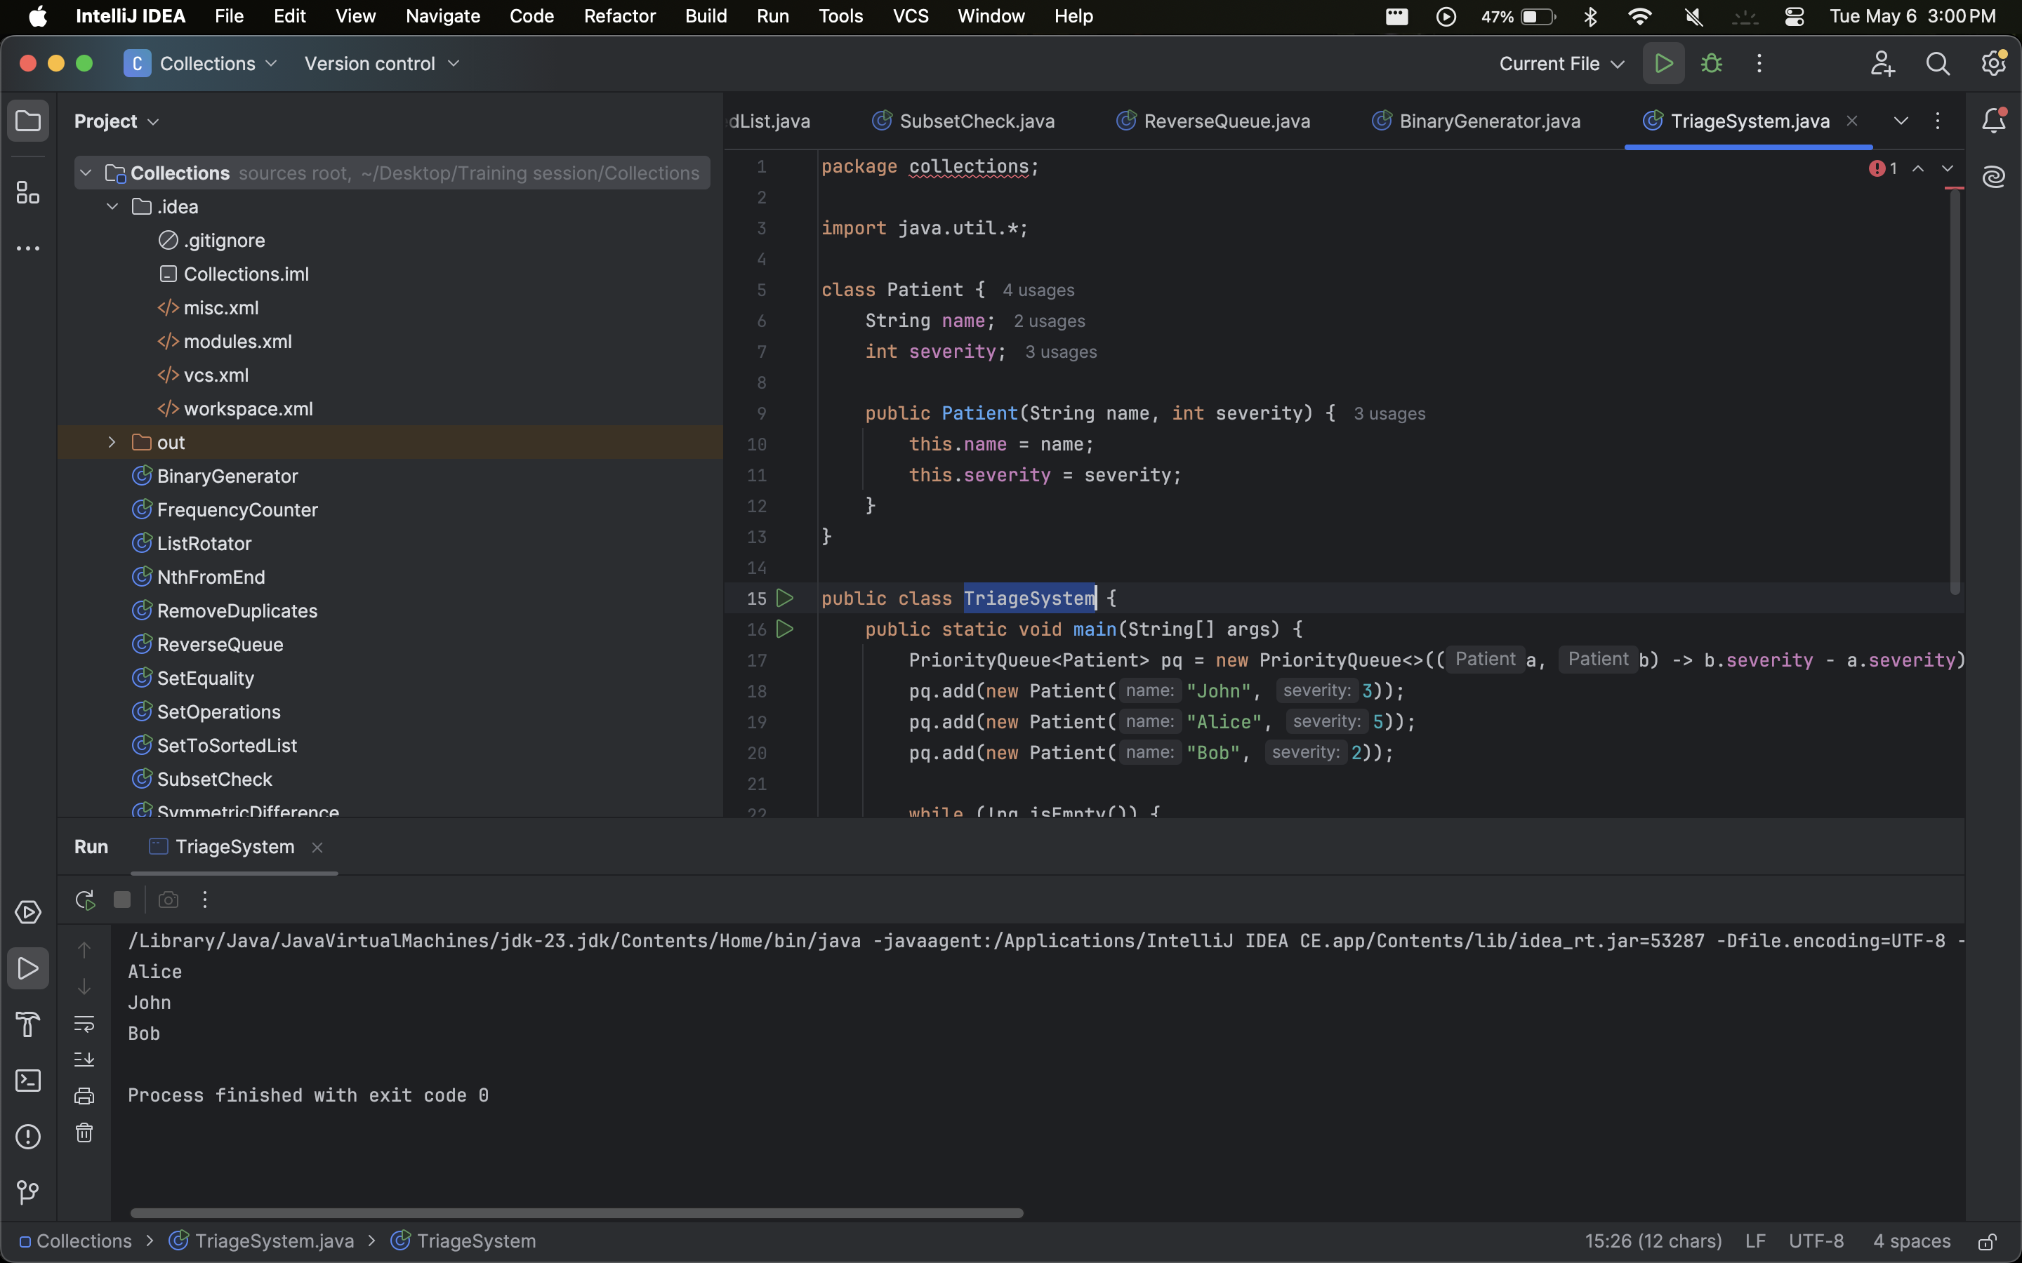

1. **Implement a Stack Using Queues**Implement a stack data structure using two queues and support push, pop, and top operations.  
   **Example**:  
   Push 1, 2, 3 → Pop → Output: 3.

|  |
| --- |
| package collections;  import java.util.*;  public class StackUsingQueues {  Queue<Integer> q1 = new LinkedList<>();  Queue<Integer> q2 = new LinkedList<>();   void push(int x) {  q2.add(x);  while (!q1.isEmpty())  q2.add(q1.remove());  Queue<Integer> temp = q1;  q1 = q2;  q2 = temp;  }   int pop() {  return q1.remove();  }   int top() {  return q1.peek();  }   public static void main(String[] args) {  StackUsingQueues stack = new StackUsingQueues();  stack.push(1);  stack.push(2);  stack.push(3);  System.out.println(stack.pop()); // 3  } } |

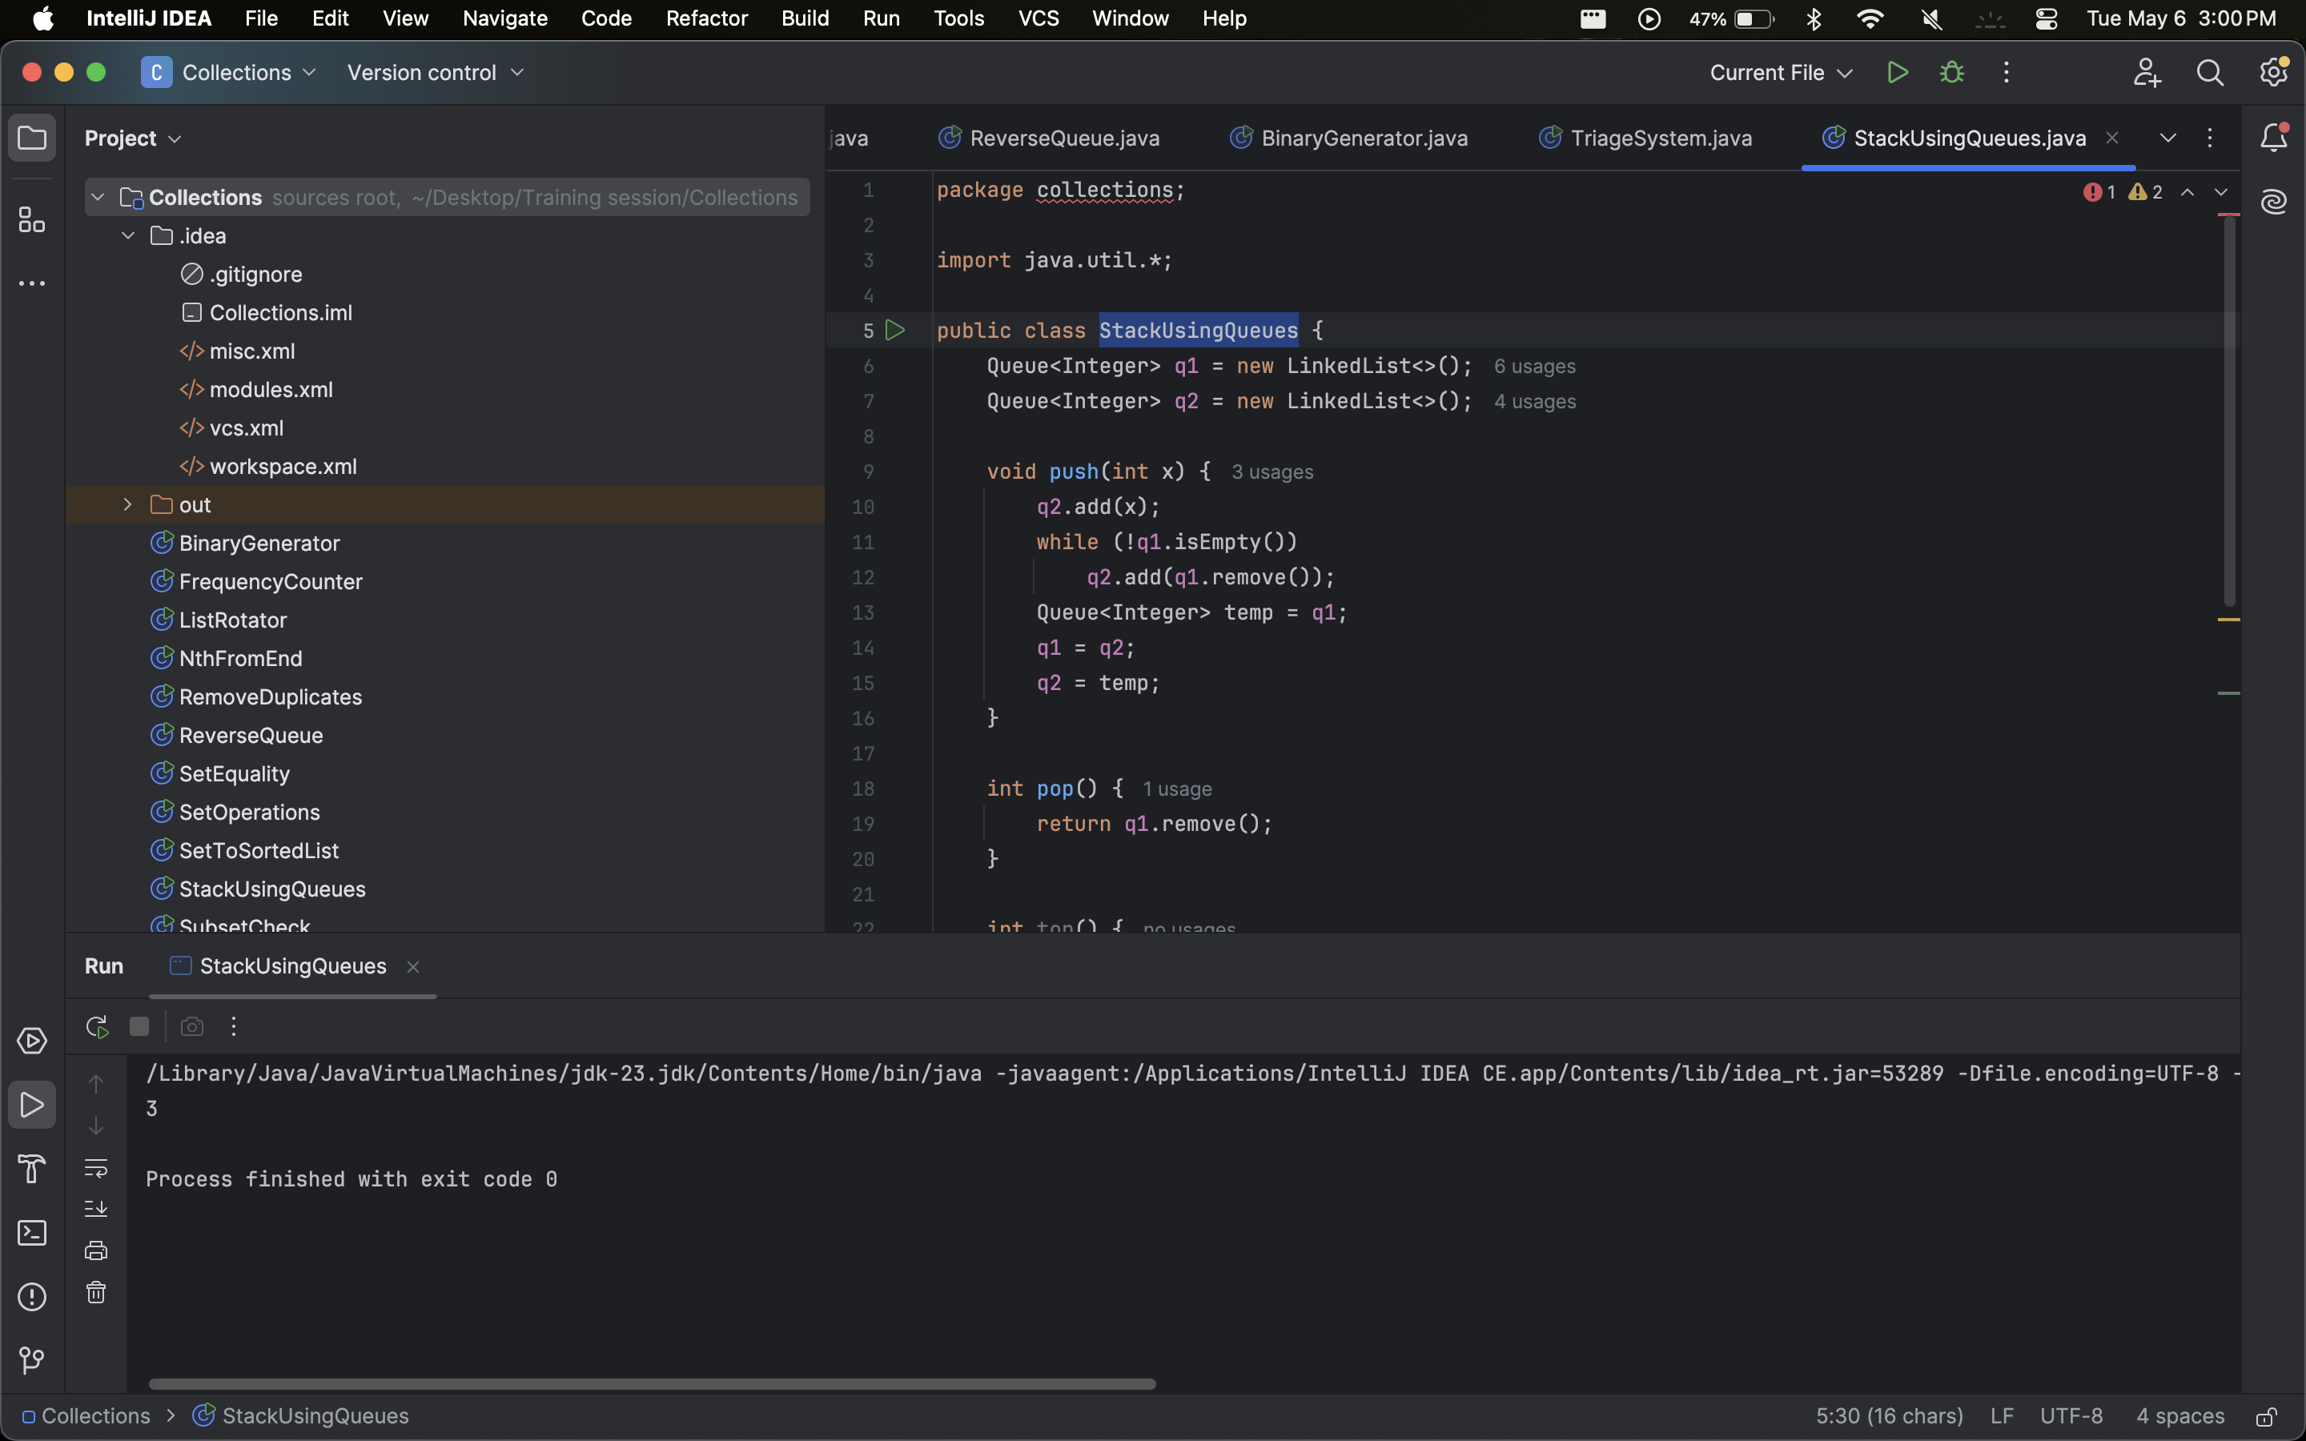

1. **Circular Buffer Simulation**Implement a circular buffer (fixed-size queue) using an array-based queue. When full, overwrite the oldest element.  
   **Example**:  
   Buffer size=3: Insert 1, 2, 3 → Insert 4 → Buffer: [2, 3, 4].

|  |
| --- |
| package collections;  import java.util.*;  public class CircularBuffer {  int[] buffer;  int size, start = 0, count = 0;   public CircularBuffer(int k) {  buffer = new int[k];  size = k;  }   void insert(int val) {  buffer[(start + count) % size] = val;  if (count < size) count++;  else start = (start + 1) % size;  }   List<Integer> getBuffer() {  List<Integer> res = new ArrayList<>();  for (int i = 0; i < count; i++) {  res.add(buffer[(start + i) % size]);  }  return res;  }   public static void main(String[] args) {  CircularBuffer cb = new CircularBuffer(3);  cb.insert(1); cb.insert(2); cb.insert(3);  cb.insert(4);  System.out.println(cb.getBuffer()); // [2, 3, 4]  } } |

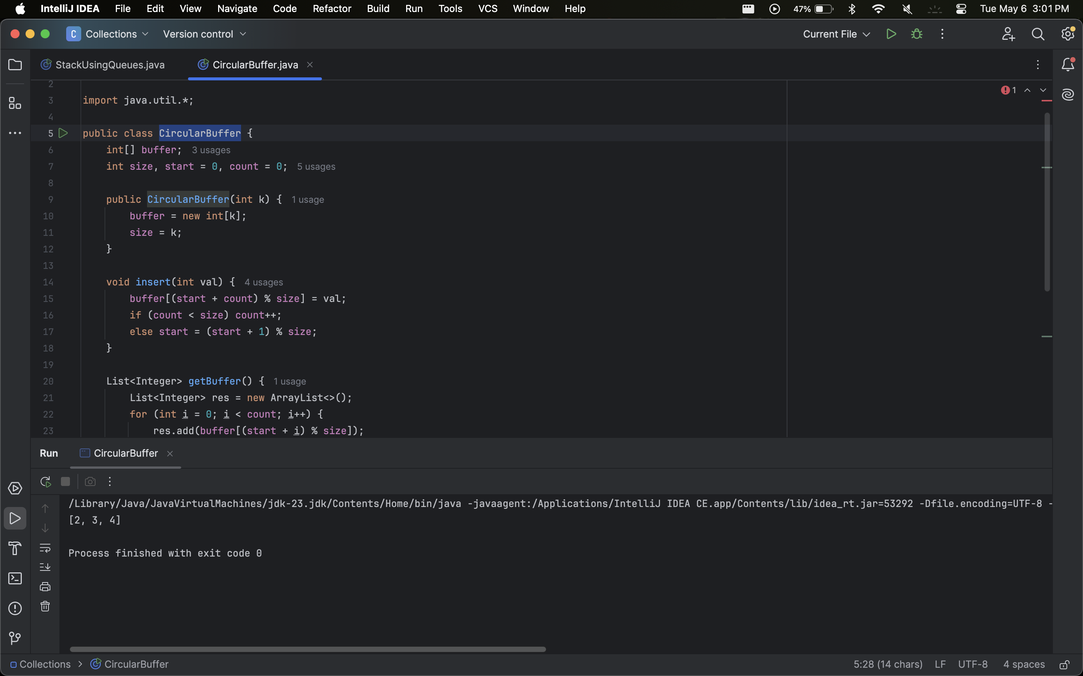

### 

# Map Interface

1. **Word Frequency Counter**Read a text file and count the frequency of each word using a HashMap. Ignore case and punctuation.  
   **Example**:  
   Input: "Hello world, hello Java!" → Output: {hello=2, world=1, java=1}

|  |
| --- |
| package collections;  import java.util.*; import java.util.regex.*;  public class WordFrequency {  public static Map<String, Integer> countWords(String text) {  Map<String, Integer> freq = new HashMap<>();  text = text.toLowerCase().replaceAll("[^a-z\\s]", "");  for (String word : text.split("\\s+")) {  freq.put(word, freq.getOrDefault(word, 0) + 1);  }  return freq;  }   public static void main(String[] args) {  String input = "Hello world, hello Java!";  System.out.println(countWords(input)); // {hello=2, world=1, java=1}  } } |

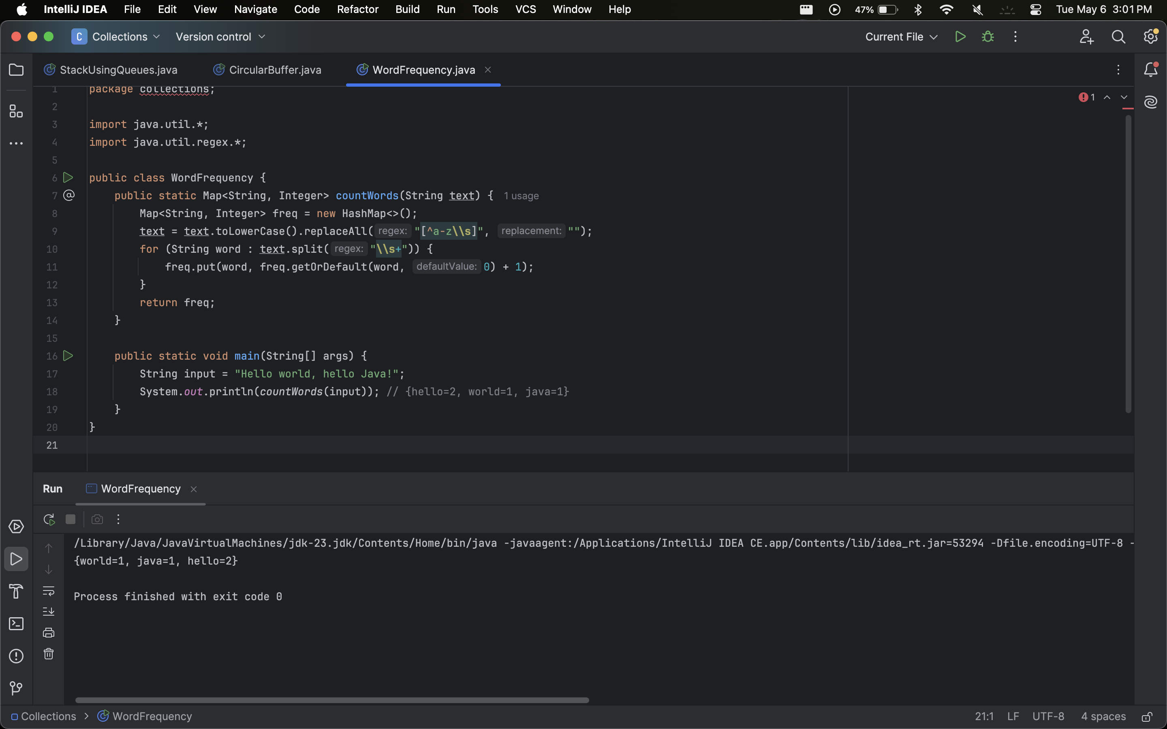

1. **Invert a Map**Invert a Map<K, V> to produce a Map<V, K>. Handle duplicate values by storing them in a list.  
   **Example**:  
   Input: {A=1, B=2, C=1} → Output: {1=[A, C], 2=[B]}.

|  |
| --- |
| package collections;  import java.util.*;  public class InvertMap {  public static <K, V> Map<V, List<K>> invert(Map<K, V> map) {  Map<V, List<K>> inverted = new HashMap<>();  for (Map.Entry<K, V> entry : map.entrySet()) {  inverted.computeIfAbsent(entry.getValue(), k -> new ArrayList<>()).add(entry.getKey());  }  return inverted;  }   public static void main(String[] args) {  Map<String, Integer> map = Map.of("A", 1, "B", 2, "C", 1);  System.out.println(invert(map)); // {1=[A, C], 2=[B]}  } } |

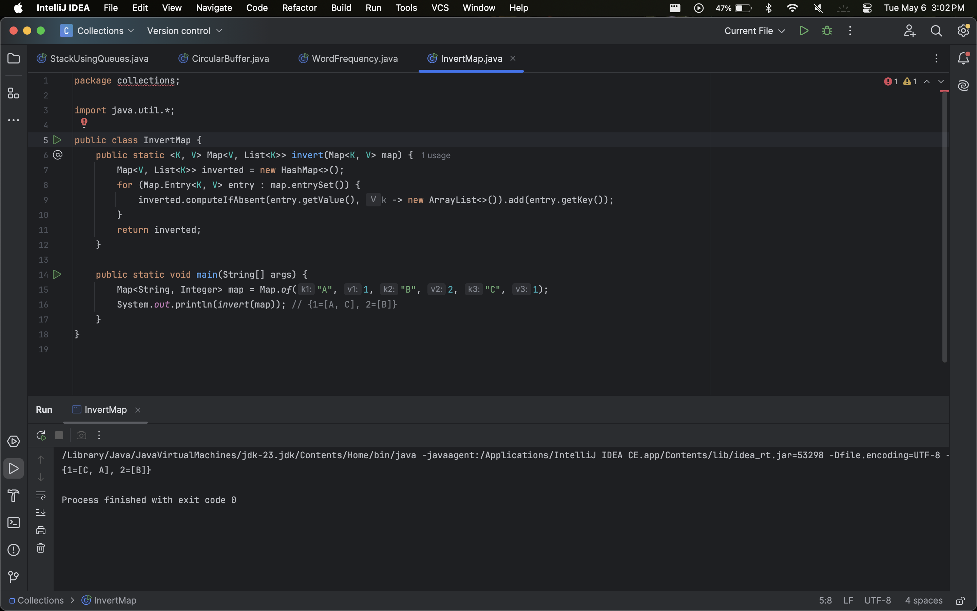

1. **Find the Key with the Highest Value**Given a Map<String, Integer>, find the key with the maximum value.  
   **Example**:  
   Input: {A=10, B=20, C=15} → Output: B.

|  |
| --- |
| package collections;  import java.util.*;  public class MaxValueKey {  public static String maxKey(Map<String, Integer> map) {  return Collections.max(map.entrySet(), Map.Entry.comparingByValue()).getKey();  }   public static void main(String[] args) {  Map<String, Integer> map = Map.of("A", 10, "B", 20, "C", 15);  System.out.println(maxKey(map)); // B  } } |

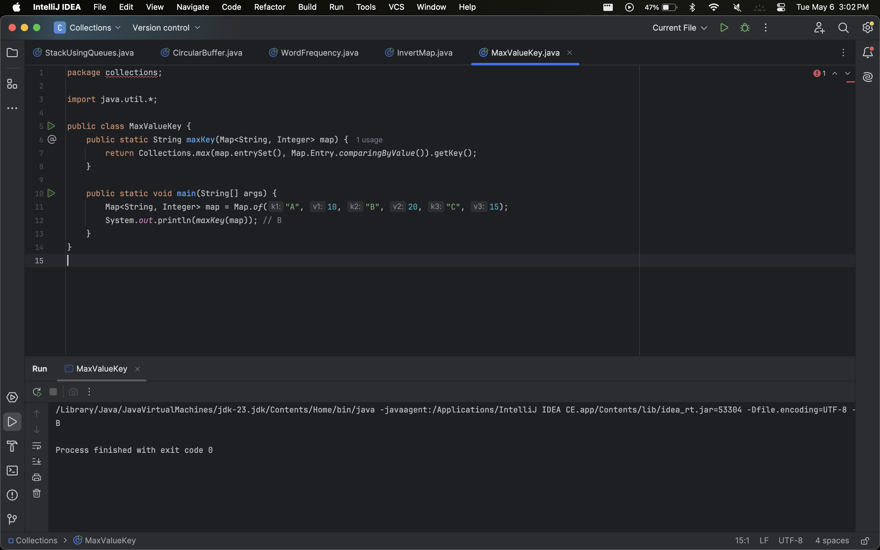

1. **Merge Two Maps**Merge two maps such that if a key exists in both, sum their values.  
   **Example**:  
   Map1: {A=1, B=2}, Map2: {B=3, C=4} → Output: {A=1, B=5, C=4}.

|  |
| --- |
| package collections;  import java.util.*;  public class MergeMaps {  public static Map<String, Integer> merge(Map<String, Integer> m1, Map<String, Integer> m2) {  Map<String, Integer> result = new HashMap<>(m1);  for (var entry : m2.entrySet()) {  result.merge(entry.getKey(), entry.getValue(), Integer::sum);  }  return result;  }   public static void main(String[] args) {  Map<String, Integer> m1 = Map.of("A", 1, "B", 2);  Map<String, Integer> m2 = Map.of("B", 3, "C", 4);  System.out.println(merge(m1, m2)); // {A=1, B=5, C=4}  } } |

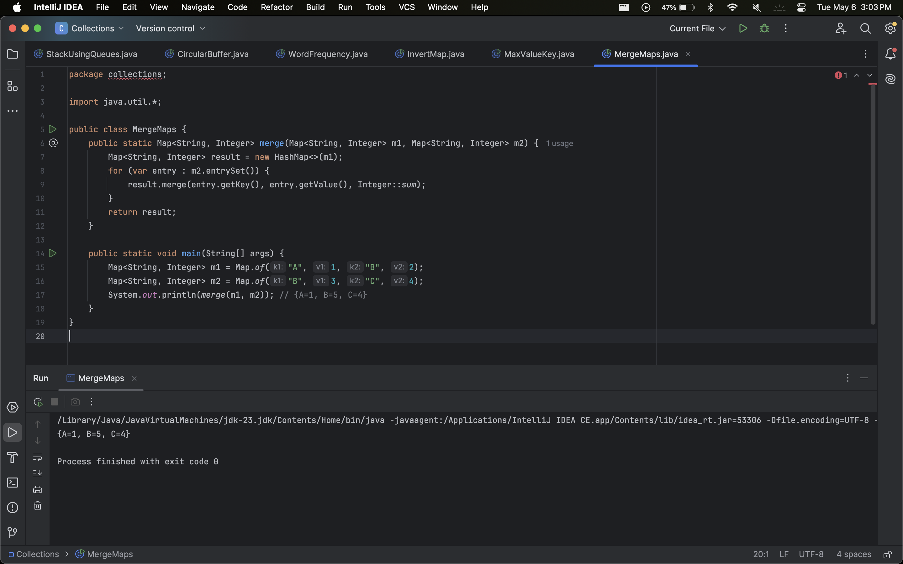

1. **Group Objects by Property**Given a list of Employee objects, group them by their department using a Map<Department, List<Employee>>.  
   **Example**:  
   Employees: [Alice (HR), Bob (IT), Carol (HR)] → Output: HR: [Alice, Carol], IT: [Bob].

|  |
| --- |
| package collections;  import java.util.*;  class Employee {  String name;  String department;   public Employee(String name, String department) {  this.name = name;  this.department = department;  }   public String toString() {  return name;  } }  public class GroupByDepartment {  public static Map<String, List<Employee>> group(List<Employee> employees) {  Map<String, List<Employee>> grouped = new HashMap<>();  for (Employee emp : employees) {  grouped.computeIfAbsent(emp.department, k -> new ArrayList<>()).add(emp);  }  return grouped;  }   public static void main(String[] args) {  List<Employee> employees = List.of(  new Employee("Alice", "HR"),  new Employee("Bob", "IT"),  new Employee("Carol", "HR")  );  System.out.println(group(employees));  // Output: {HR=[Alice, Carol], IT=[Bob]}  } } |

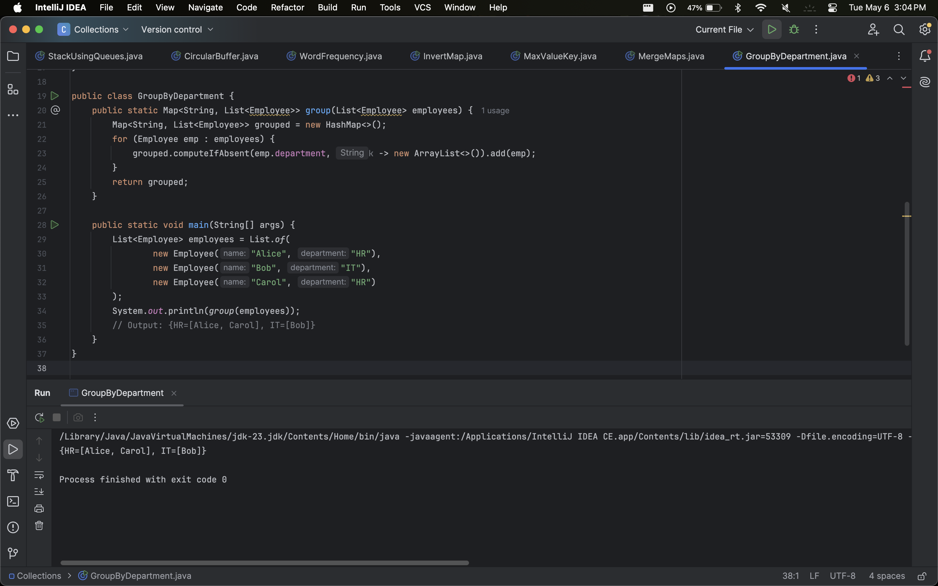

**Insurance Policy Management System**

Build a system for managing insurance policies where you have to:

* Store and manage policies with unique identifiers.
* Retrieve and manipulate policies based on different criteria.
* Track policies by various attributes such as policyholder name and expiry date.

Requirements:

1. Store Policies in a Map:

* Use HashMap to store policies with policy numbers as keys and policy
* details as values.
* Use LinkedHashMap to maintain the insertion order of policies.
* Use TreeMap to store policies sorted by expiry date.

2. Retrieve and Manipulate Policies:

1. Implement methods to:

* Retrieve a policy by its number.
* List all policies expiring within the next 30 days.
* List all policies for a specific policyholder.
* Remove policies that are expired.

### **Design a Voting System**

**Description**: Design a system where:

* Votes are stored in a HashMap (Candidate -> Votes).
* TreeMap is used to display the results in sorted order.
* LinkedHashMap is used to maintain the order of votes.

### 

### 

### 

### **Implement a Shopping Cart**

**Description**:

* Use HashMap to store product prices.
* Use LinkedHashMap to maintain the order of items added.
* Use TreeMap to display items sorted by price.

### **Implement a Banking System**

**Description**:

* HashMap stores customer accounts (AccountNumber -> Balance).
* TreeMap sorts customers by balance.
* Queue processes withdrawal requests.